

Solution Test Bench

database MIGRation

from SQL Server Express

To SQL Server enterprise

Contents

Assumptions 2

Database Backup Procedure 2

SQL Upgrade procedure: 4

## Assumptions

* All 4 STB databases have been backed up (See Database Backup Procedure)
* STB was initially Installed with SQL Server Express 2014 instance

## Database Backup Procedure

1. To make this process go as smoothly as possible, make sure that the SQL Server Management Studio is present on the STB Server machine. This may require you to install it before continuing.
2. Open the SQL Server Management Studio
3. Select the Database and Click on Connect, provide credentials if prompted
4. Expand the Databases tree and select the **ScalableTestDatalog** database

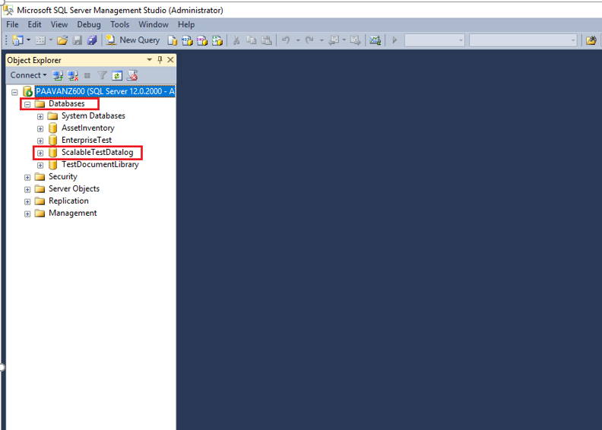

1. Right click on **ScalableTestDatalog** database and navigate to the Tasks menu and click on Back Up

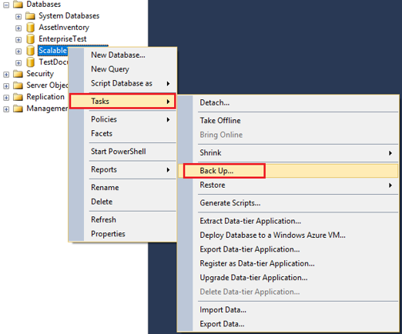

1. Under Back Up Database window, provide file name and destination path and click on OK.

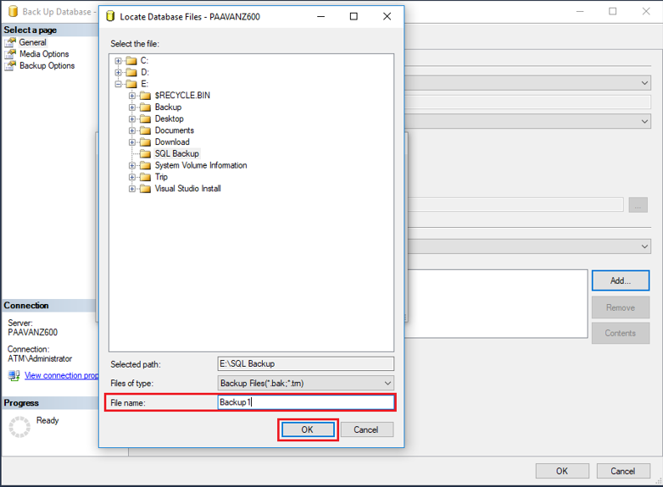

1. Repeat steps 5 and 6 for the following databases: **AssetInventory**, **EnterpriseTest, TestDocumentLibrary**

## SQL Upgrade procedure:

1. Stop the “hpstbds” Service on STB installed Server machine

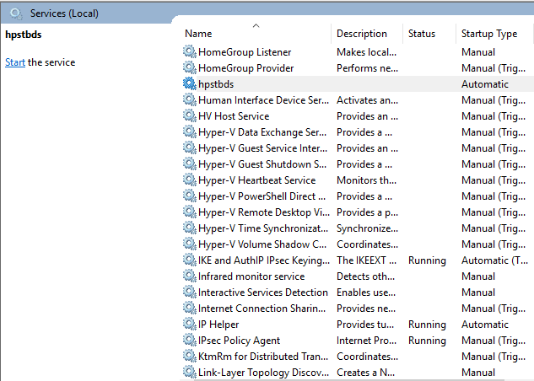

1. Run SQL 2017 Enterprise Setup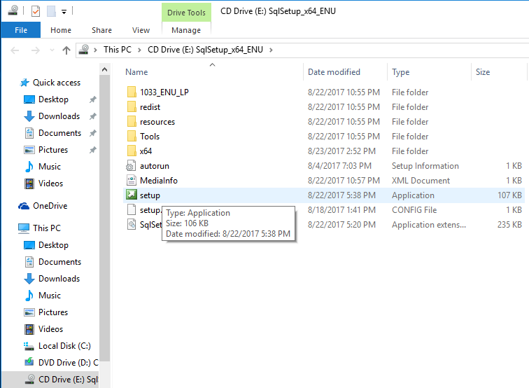
2. Click on installation menu

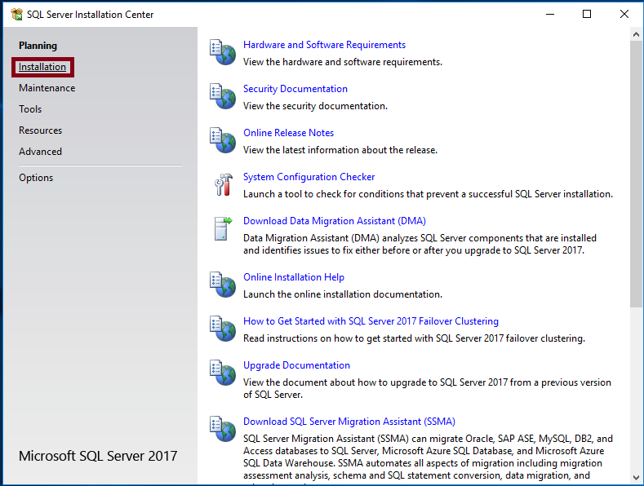

1. Select “**Upgrade from a previous version of SQL server**” option under the installation menu

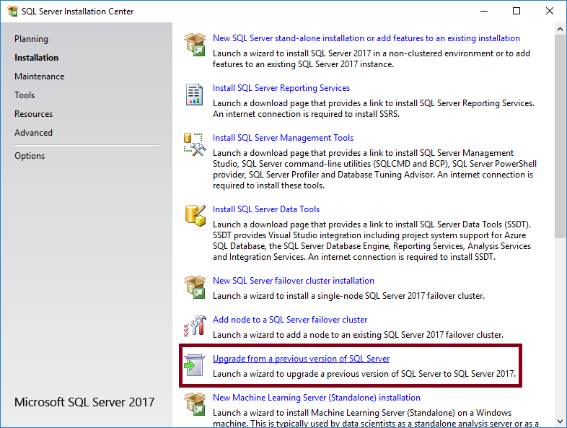

1. Proceed the SQL installation with default instance 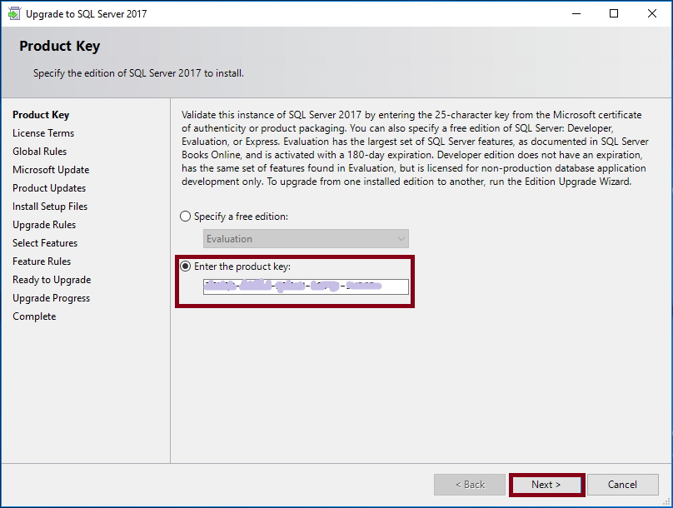

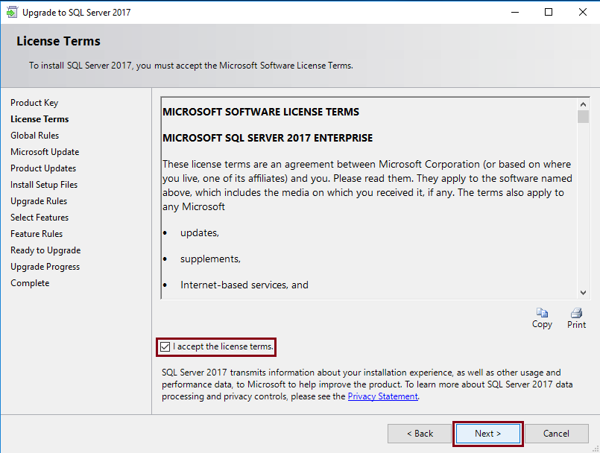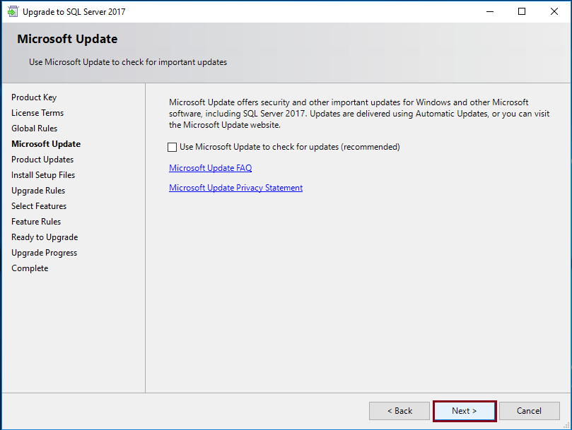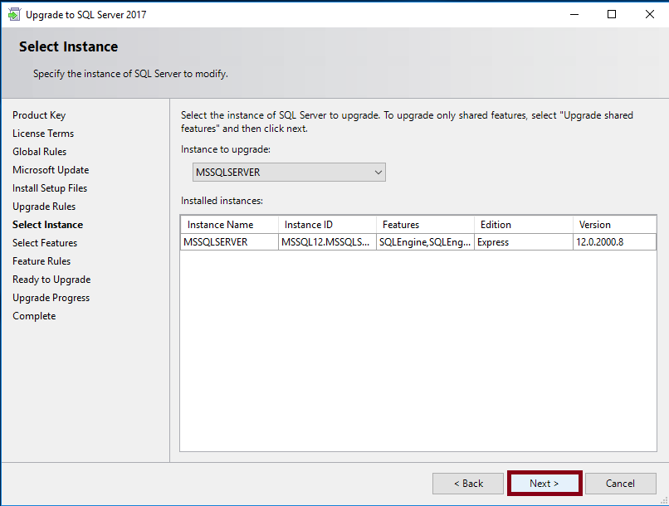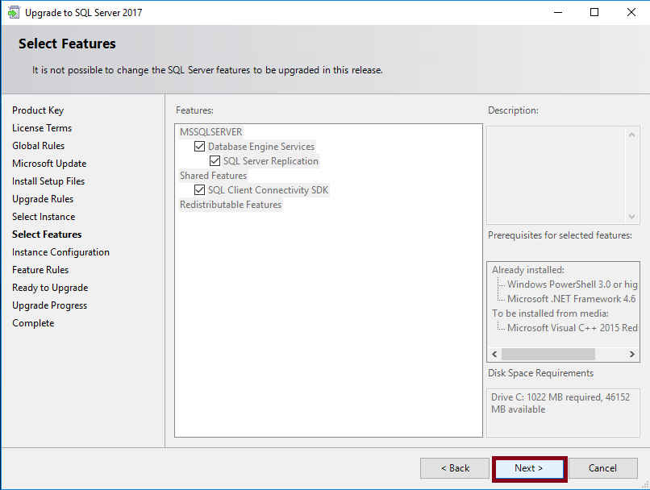

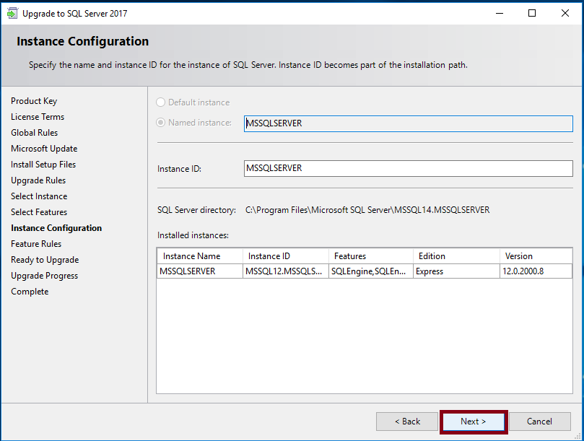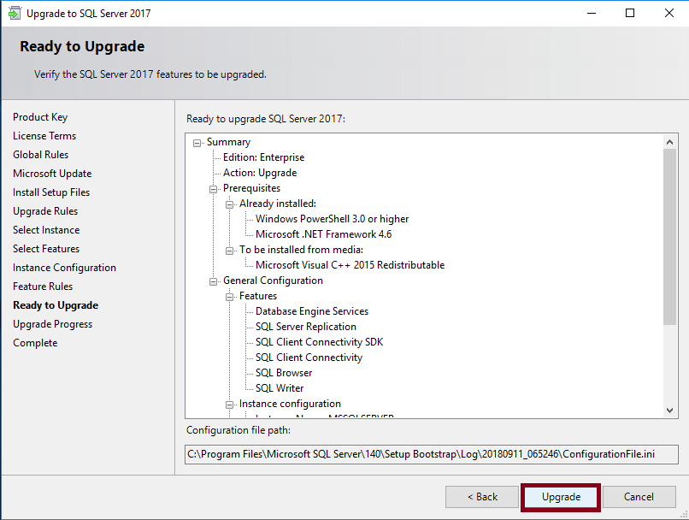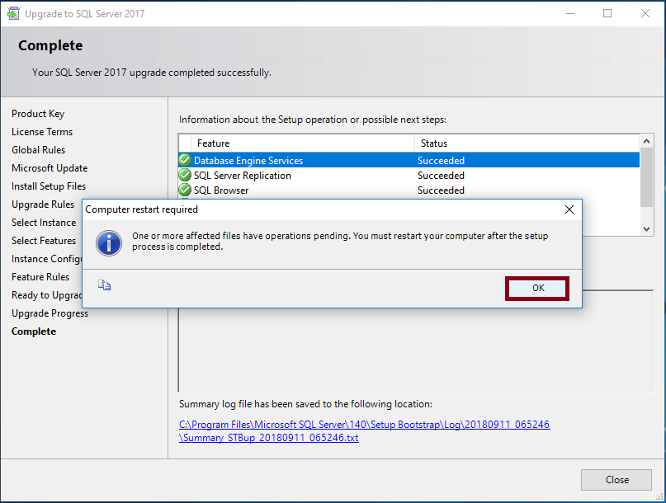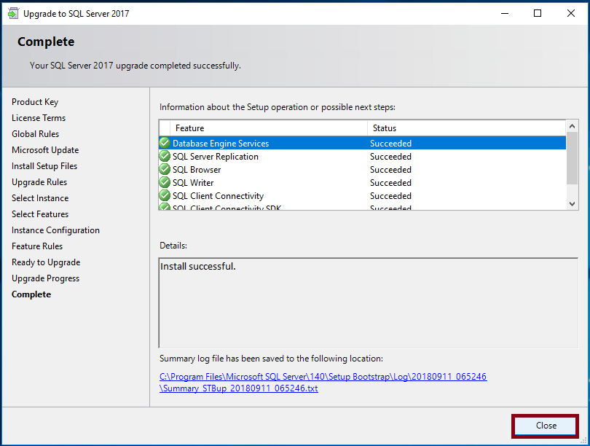

1. Once the installation completes restart the machine
2. Once the machine is ready, Turn on the “hpstbds” service
3. Launch STB and verify whether the installation completed successfully.

